***Getting Started on Git and GitHub***

Majella 6/4/2024 - My first attempt to clone our group Repository to my own local directory using ‘git clone’ in GitBash (GIT) and using the https address location of the repo failed.



My initial attempts using SSH path also failed several times due to not having an SSH key set up on my computer which safely identifies my device to GitHub and links this to my GitHub account.

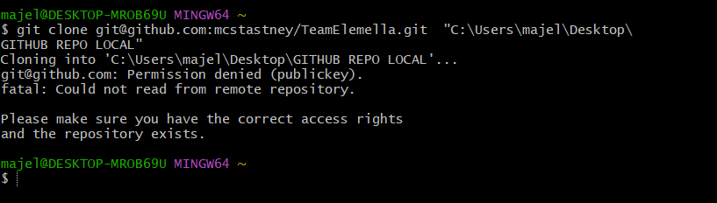

To remedy this you need to set up **a SSH key and password** using Windows PowerShell and link this to my GitHub account.

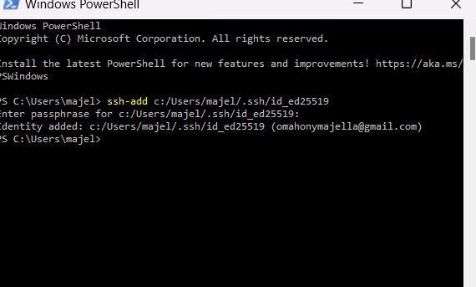

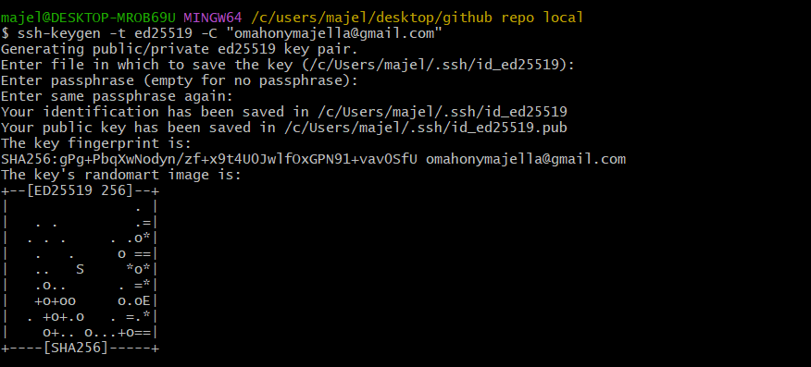

I was then able to CLONE our repository to my local directory using command ‘git clone’

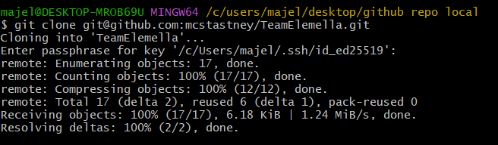

Important for anyone being invited to collaborate or join the repository who is new to GitHub and using a shared repository for the first time to be aware of the need to check for existing SSH keys on their local directory, i.e. where to locate it, or alternatively if they do not have one, to know how to generate a new SSH key as you will need to address this step prior to attempting cloning to get access to the repository.

More information/used these notes to help:

<https://docs.github.com/en/authentication/connecting-to-github-with-ssh/generating-a-new-ssh-key-and-adding-it-to-the-ssh-agent>